WCP Product Research Tool Design Prototype V2.1

# Login Page:

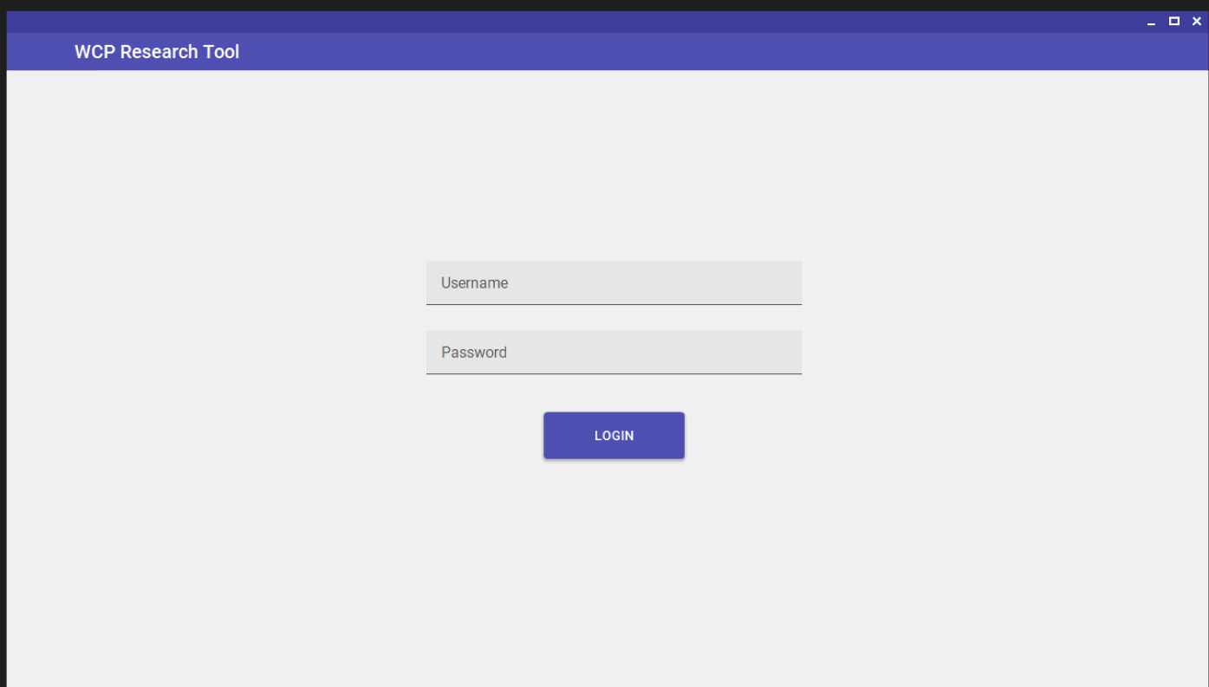

Main Page:  
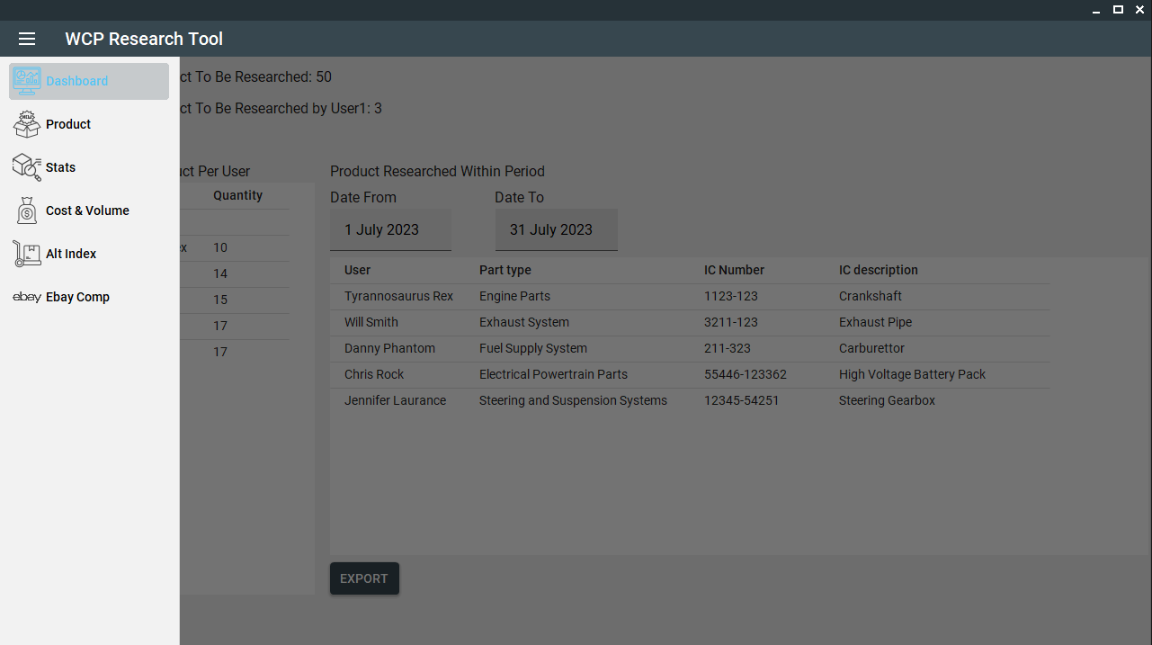

## Dashboard Tab

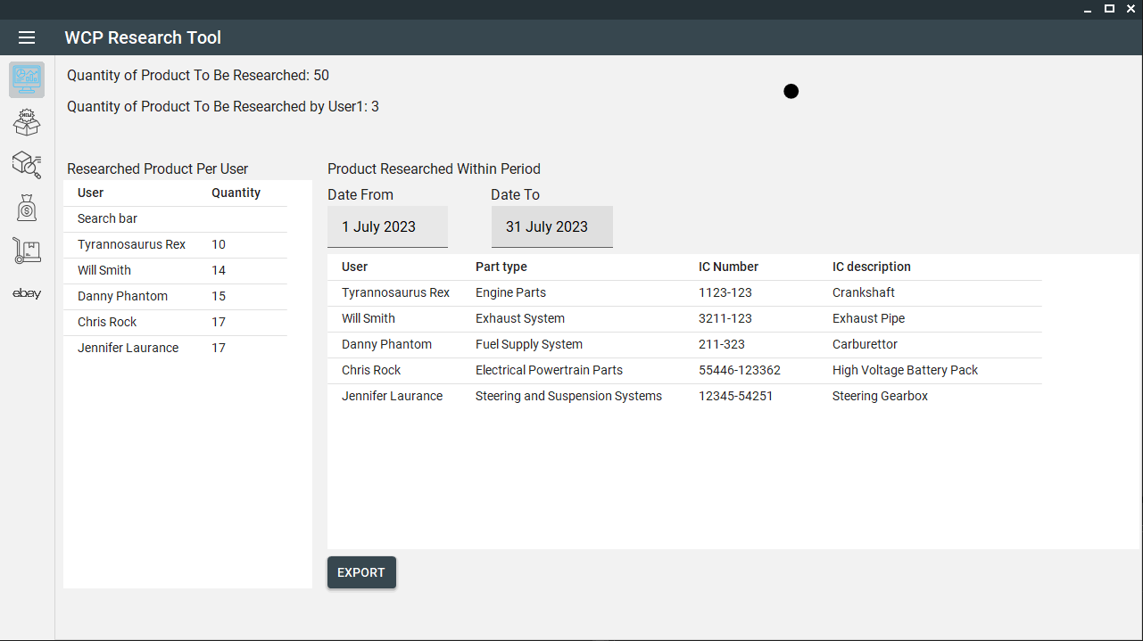

## Product Tab

## Stats Tab

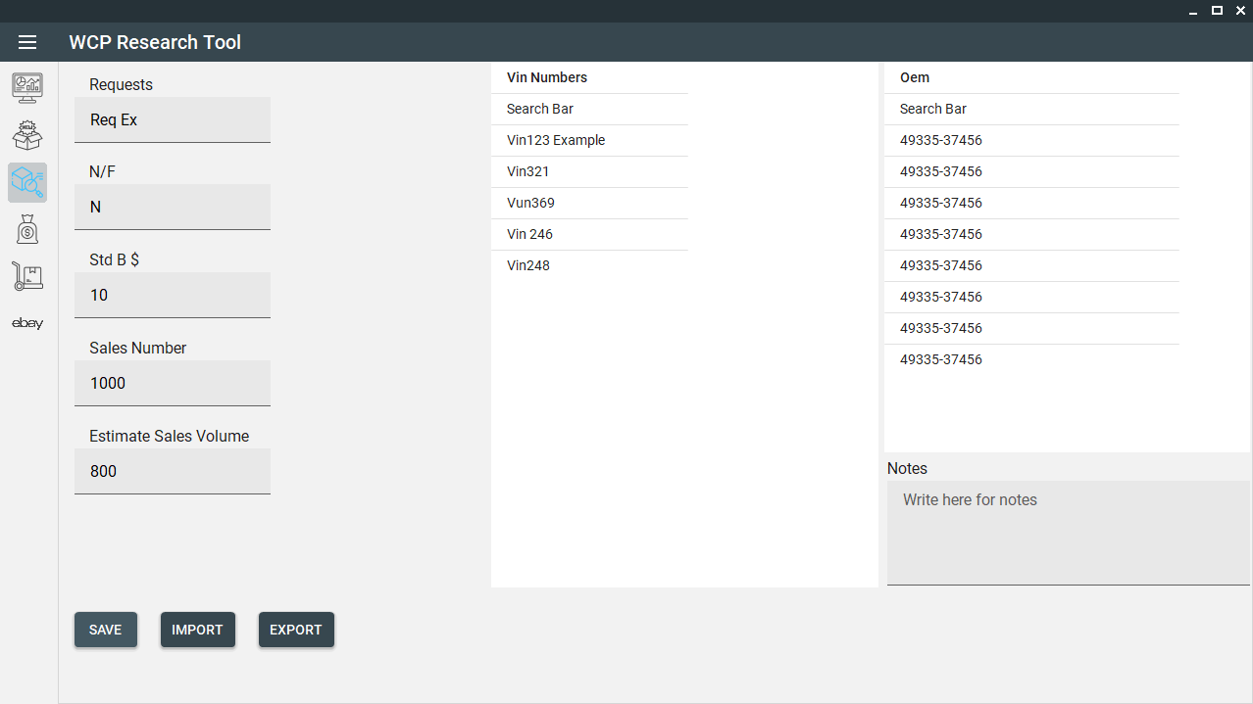

## Cost & Volume Tab

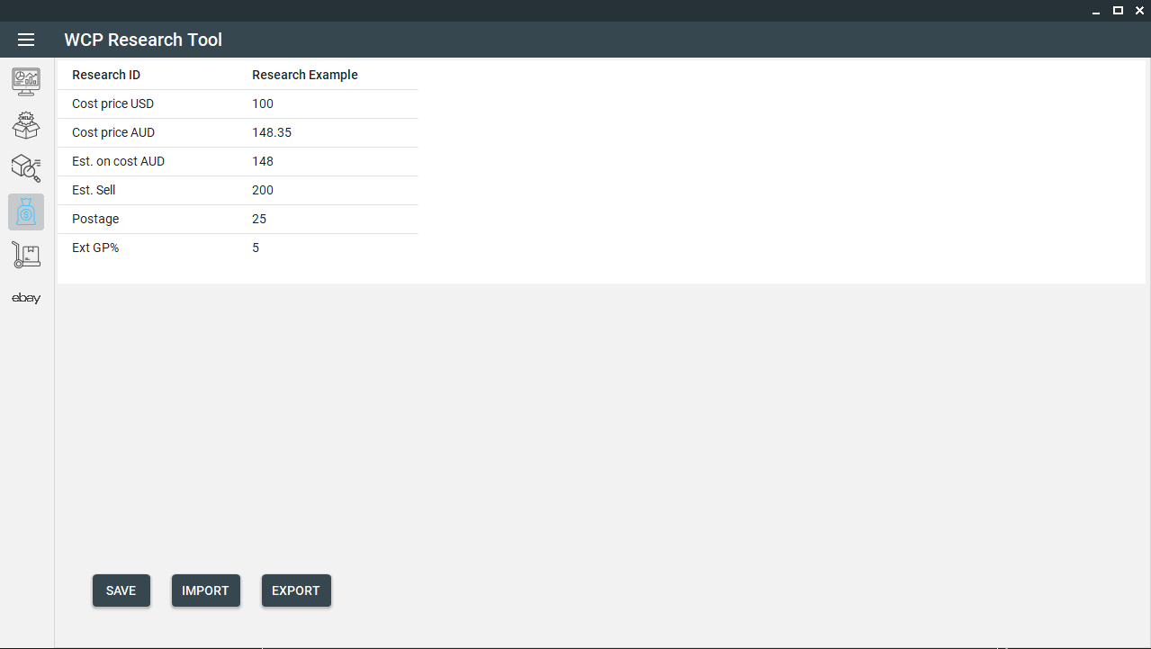

Alternate Index Detail Tab  
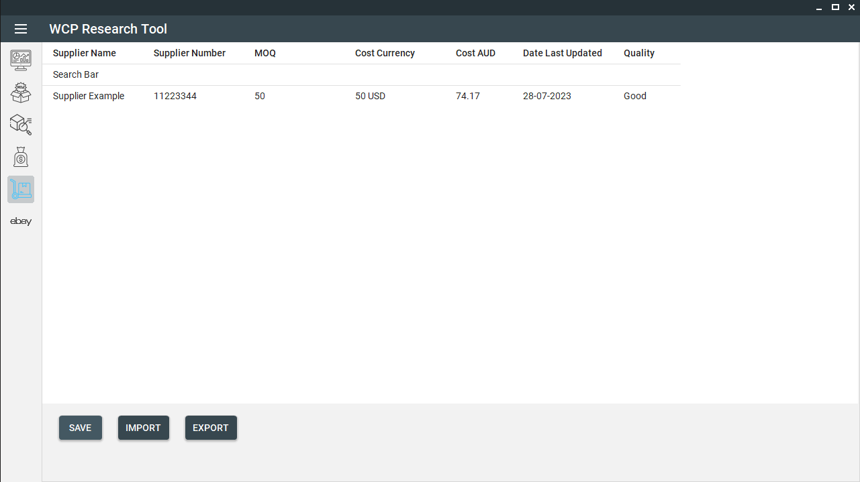

Ebay Tab  
